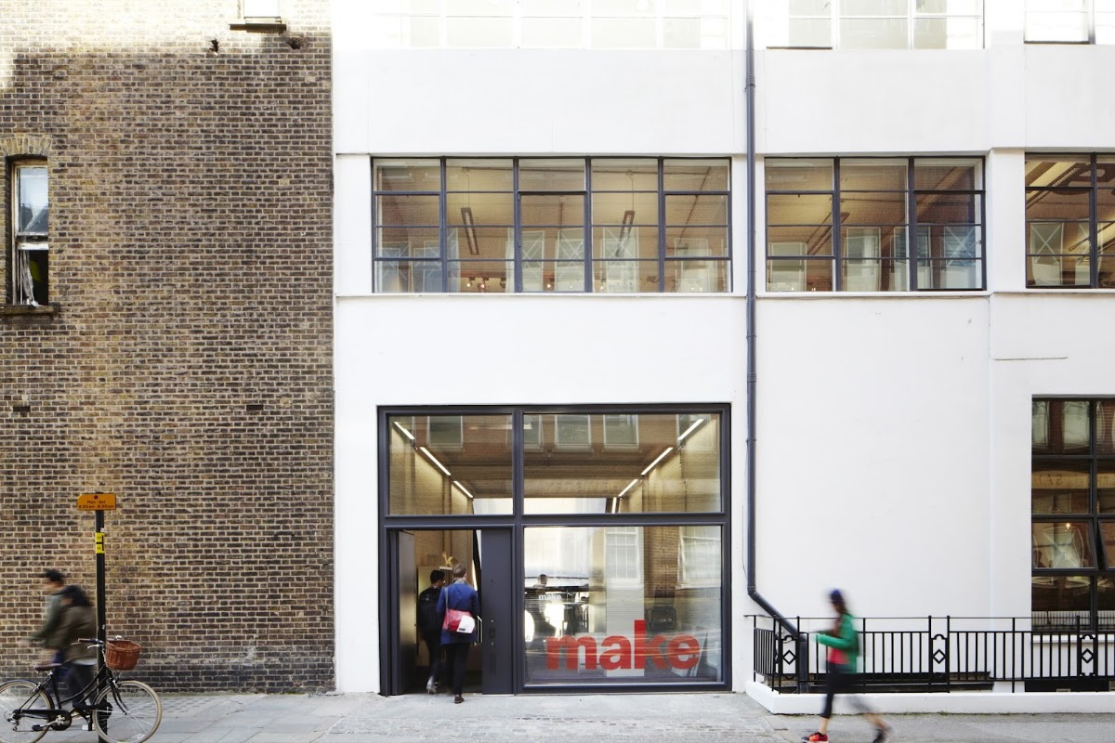

LONDON ACCOMMODATION RECOMMENDATIONS
Curated by Bon Voyage By Marina
Prepared Exclusively For
BUSHAN
TRIP SNAPSHOT
Destination | London
Travellers | 2 adults
Stay Requirements | Refundable Booking • Breakfast Included

A NOTE FROM BON VOYAGE BY MARINA
Thank you for giving us the opportunity to assist with your London journey. The options in this document have been carefully reviewed and shortlisted based on your preferences, location requirements, flexibility, and overall value. We hope this guide helps you choose the stay that is right for you.

Bon Voyage By Marina
Bespoke Travel Planning • Premium Stays • Seamless Experiences
📞 +91 86000 15316 | 📸 @bonvoyagebymarina | 🌐 www.bonvoyagebymarina.com
✈️ Crafting unforgettable journeys, one trip at a time.

Executive Summary
Compare all accommodation options at a glance.
City / Dates | Hotel | Online Price | Our Price | You Save
Wimbledon (Jun 28 - Jul 4) | Travelodge London Raynes Park | ₹1,81,286 | ₹1,78,286 | ₹3,000  (1.7% off)
Wimbledon (Jun 28 - Jul 1) | Travelodge London Raynes Park (2*) | ₹93,069 | ₹88,419 | ₹4,650  (5.0% off)
Wimbledon (Jun 28 - Jul 1) | The Lodge Hotel - Putney (4*) | ₹1,37,188 | ₹1,28,288 | ₹8,900  (6.5% off)
Central London (Jul 1 - Jul 4) | Copthorne Tara Hotel London Kensington (4*) | ₹97,953 | ₹89,153 | ₹8,800  (9.0% off)
Central London (Jul 1 - Jul 4) | Hilton London Kensington (4*)  ★ RECOMMENDED | ₹1,04,452 | ₹95,052 | ₹9,400  (9.0% off)
Central London (Jul 1 - Jul 4) | Park Plaza Westminster Bridge London (4*) | ₹1,75,007 | ₹1,54,007 | ₹21,000  (12.0% off)

WIMBLEDON (JUN 28 - JUL 4)

Travelodge London Raynes Park

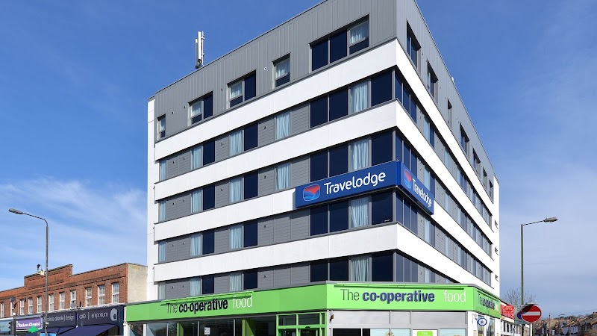
🛏️ Room: 1 x Double Room
⭐ Guest Rating: 3.9/5 (640 reviews)
🔄 Cancellation: Non-refundable
🍳 Breakfast: Breakfast included
Situated in the quiet residential neighbourhood of Raynes Park in southwest London, this hotel offers a calm retreat away from the city's busier zones while keeping central London well within reach via the direct rail connection from Raynes Park station. It suits travellers who prefer a quieter base and value straightforward, comfortable accommodation without the noise and premium pricing of more central postcodes. Breakfast is included, adding ease to morning departures. The 3.9 rating across 640 reviews reflects consistent guest satisfaction. Please note this rate is non-refundable.

Online Price | ₹1,81,286
Our Price | ₹1,78,286
You Save | ₹3,000 (1.7% off best online prices)

WIMBLEDON (JUN 28 - JUL 1)

Travelodge London Raynes Park


🛏️ Room: 1 x Double Room
⭐ Guest Rating: 3.9/5 (640 reviews)
🔄 Cancellation: Non-refundable
🍳 Breakfast: Breakfast included
Situated in the quiet residential neighbourhood of Raynes Park in southwest London, this hotel offers a calm retreat away from the city's busier zones while keeping central London well within reach via the direct rail connection from Raynes Park station. It suits travellers who prefer a quieter base and value straightforward, comfortable accommodation without the noise and premium pricing of more central postcodes. Breakfast is included, adding ease to morning departures. The 3.9 rating across 640 reviews reflects consistent guest satisfaction. Please note this rate is non-refundable.

Online Price | ₹93,069
Our Price | ₹88,419
You Save | ₹4,650 (5.0% off best online prices)

The Lodge Hotel Putney

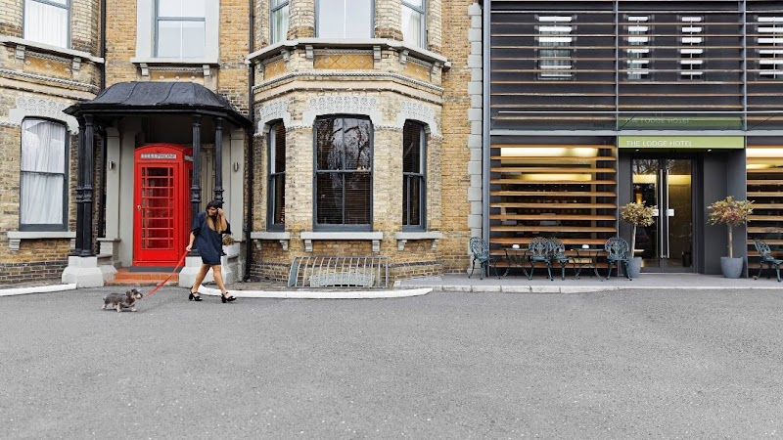
🛏️ Room: Classic Double Room
🏨 Category: 4-Star
⭐ Guest Rating: 4.4/5 (696 reviews)
🔄 Cancellation: Free cancellation till 26 Jun
🍳 Breakfast: Breakfast included
Situated on Upper Richmond Road in Putney, The Lodge Hotel places guests in one of southwest London's most pleasant residential neighbourhoods — well-connected by tube and overground into the West End, yet noticeably quieter than central London. This four-star property suits travellers who prefer a more relaxed base without sacrificing access to the city's key attractions. With a strong 4.4 rating across nearly 700 reviews, it consistently delivers on comfort and service. Breakfast is included, and free cancellation is available until 26th June — giving you full flexibility as plans take shape.

Online Price | ₹1,37,188
Our Price | ₹1,28,288
You Save | ₹8,900 (6.5% off best online prices)

CENTRAL LONDON (JUL 1 - JUL 4)

Copthorne Tara Hotel London Kensington

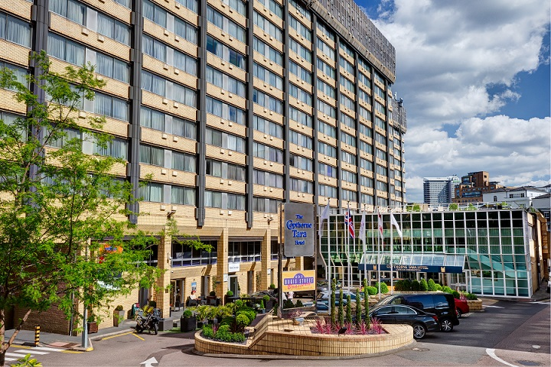
🛏️ Room: Standard Double Room
🏨 Category: 4-Star
⭐ Guest Rating: 3.9/5 (9,627 reviews)
🔄 Cancellation: Free cancellation till 29 Jun
🍳 Breakfast: Breakfast included
Positioned in the heart of Kensington, the Copthorne Tara places you within easy reach of some of London's finest — Hyde Park, the Victoria & Albert Museum, and the boutiques of High Street Kensington are all minutes away. This is a well-established four-star property that suits travellers who want a calm, residential neighbourhood without sacrificing central access. Breakfast is included, and with free cancellation until 29th June, your plans remain flexible. Rated highly across nearly ten thousand reviews, it offers the consistency and scale that make a London stay genuinely effortless.

Online Price | ₹97,953
Our Price | ₹89,153
You Save | ₹8,800 (9.0% off best online prices)

Hilton London Kensington ★ RECOMMENDED

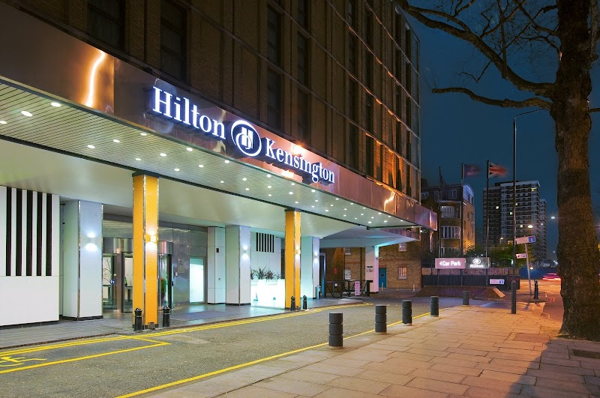
🛏️ Room: DOUBLE HILTON GUESTROOM
🏨 Category: 4-Star
⭐ Guest Rating: 3.8/5 (5,278 reviews)
🔄 Cancellation: Free cancellation till 29 Jun
🍳 Breakfast: Breakfast included
Positioned on Holland Park Avenue, this Hilton sits in one of London's most graceful residential neighbourhoods — leafy, unhurried, and genuinely well-connected. Notting Hill, Portobello Road, and Holland Park are all within easy reach, while the Central line puts the rest of the city comfortably close. It suits travellers who prefer a quieter base without sacrificing convenience or the reassurance of a well-run international property. Breakfast is included, and the rate carries free cancellation until 29th June, offering useful flexibility as plans take shape.

Online Price | ₹1,04,452
Our Price | ₹95,052
You Save | ₹9,400 (9.0% off best online prices)

Park Plaza London Westminster Bridge

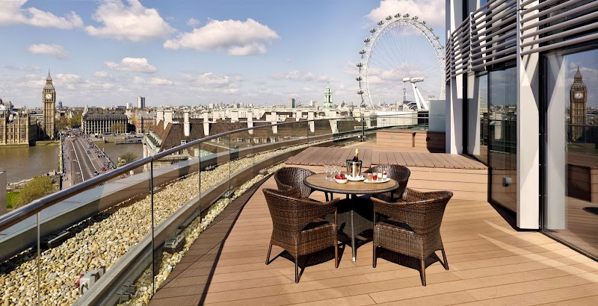
🛏️ Room: Superior Room-1 King
🏨 Category: 4-Star
⭐ Guest Rating: 4.5/5 (13,941 reviews)
🔄 Cancellation: Free cancellation till 28 Jun
🍳 Breakfast: Breakfast included
Positioned directly on the South Bank, Park Plaza Westminster Bridge places you steps from the Thames, with the Houses of Parliament and Westminster Bridge visible from the hotel itself. This is a polished, contemporary property that suits both couples and families travelling to London — spacious rooms, a full-service spa, rooftop pool, and multiple dining options make it genuinely self-contained. Rated 4.5 across nearly 14,000 reviews, the consistency here speaks for itself. Breakfast is included, and free cancellation is available until 28th June.

Online Price | ₹1,75,007
Our Price | ₹1,54,007
You Save | ₹21,000 (12.0% off best online prices)

Thank You
Thank you for giving Bon Voyage By Marina the opportunity to assist with your London journey. We hope the accommodation options in this document help you find the stay that best matches your travel style, preferences, and budget.
Should you wish to explore additional options, alternative locations, upgraded room categories, or other travel arrangements, we would be delighted to assist.
We look forward to helping create an unforgettable London experience for you.
Warm regards,
Bon Voyage By Marina
Bespoke Travel Planning • Premium Stays • Seamless Experiences
📞 +91 86000 15316 | 📸 @bonvoyagebymarina | 🌐 www.bonvoyagebymarina.com
✈️ Crafting unforgettable journeys, one trip at a time.

